Riverside Primary School
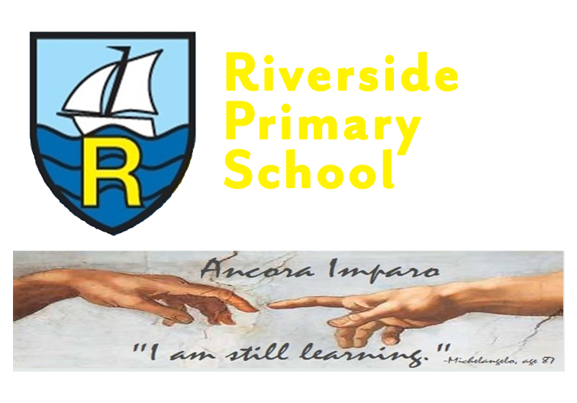
Information for Parents - Spring Term- Year 2
Highlights of the Autumn term

What a start we have had! The children have settled in so well to Year 2 life and have been working really hard. Here are a few of our highlights so far:
- Our amazing KS1 Christmas Production – The Big Little Nativity.
- Being Scientists - This half term we completed lots of science experiments: testing materials, designing raincoats and testing the stretchiness of materials.
- Cuppa and Cheer! We loved being able to share with you our British Hero song and Bluebell class poem.
- We had a visit from an elf and a donkey.
- We visited our local church to learn all about The Christmas Story.
- Finally, we went to the pantomime to watch Jack and the Beanstalk. What a fantastic afternoon we had!

Enrichment Day!
Wednesday 14th February: Great Fire of London Class Workshop presented by Past Productions.

Coming Next This Term:

Maths
Pupils will be working to achieve the following objectives:
Addition and Subtraction
- Solve problems with addition and subtraction.
- Using concrete objects and pictorial representations, including those involving numbers, quantities and measures.
- Applying their increasing knowledge of mental and written methods.
- Recall and use addition and subtraction facts to 20 fluently, and derive and use related facts up to 100.
- Add and subtract (using concrete objects, pictorial representations) two-digit numbers and ones, two-digit numbers and tens and three one-digit numbers.
- Show that addition of two numbers can be done in any order (commutative) and subtraction of one number from another cannot.
- Recognise and use the inverse relationship between addition and subtraction and use this to check calculations and solve missing number problems.

Geometry: Properties of shape
- Identify and describe the properties of 2-D shapes, including the number of sides and line symmetry in a vertical line.
- Identify and describe the properties of 3-D shapes, including the number of edges, vertices and faces.
- Identify 2-D shapes on the surface of 3-D shapes, [for example, a circle on a cylinder and a triangle on a pyramid]
- Compare and sort common 2-D and 3-D shapes and everyday objects.

Measurement: Money
- Recognise and use symbols for pounds (£) and pence (p); combine amounts to make a particular value.
- Find different combinations of coins that equal the same amounts of money.
- Solve simple problems in a practical context involving addition and subtraction of money of the same unit, including giving change.

Number: Multipication & Division
- Recall and use multiplication and division facts for the 2, 5 and 10 multiplication tables, including recognising odd and even numbers.
- Calculate mathematical statements for multiplication and division within the multiplication tables and write them using the multiplication (×), division (÷) and equals (=) signs.
- Show that multiplication of two numbers can be done in any order (commutative) and division of one number by another cannot.
- Solve problems involving multiplication and division, using materials, arrays, repeated addition, mental methods, and multiplication and division facts, including problems in contexts.

Measurement: Length and Height & Mass, Capacity and Temperature.
- Choose and use appropriate standard units to estimate and measure length/height in any Direction (m/cm); mass (kg/g); temperature (°C); capacity (litres/ml) to the nearest appropriate unit, using rulers, scales, thermometers and measuring vessels
- Compare and order lengths, mass, volume/capacity and record the results using >, < and =

English
- Pupils will be studying: The Great Fire of London by Emma Adams.
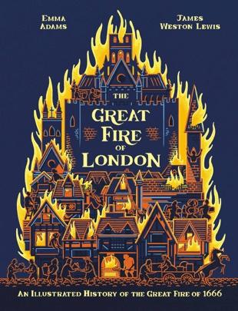

- They will write a non-fiction report.
- Pupils will continue to focus on accurate punctuation of capital letters and full stops, and begin to include question marks, exclamation marks and commas to separate items in a list.
- Pupils will orally rehearse ideas and write expanded noun phrases to add more detail.
- Pupils will use conjunctions and/because to extend sentences. They will learn to use but/or to join two contrasting ideas.
- Pupils will focus on handwriting ensuring that letters are the correct size relative to one another.

Read Write, Inc Phonics and RWI Comprehension
- Pupils will develop reading fluency and read with comprehension.
- Pupils will develop co-operative behaviour and articulate their ideas and understanding.
- Pupils will continue to spell and write with confidence.

Science

Living Things and Their Habitats

- Explore and compare the differences between things that are living, dead, and things that have never been alive.
- Identify that most living things live in habitats to which they are suited and describe how different habitats provide for the basic needs of different kinds of animals and plants, and how they depend on each other.
- Identify and name a variety of plants and animals in their habitats, including microhabitats.
- Describe how animals obtain their food from plants and other animals, using the idea of a simple food chain, and identify and name different sources of food.
Animals including Humans (Life Cycles)
- Learn how to order the stages of the Human Life Cycle.
- Describe the stages of life from adulthood to old age.
- Explore the life cycle of a chicken, butterfly and frog.
P.E

Year 2 will have P.E on Friday afternoon. Pupils should continue to come into school in their Riverside PE kit.

Gymnastics & Dance

- Pupils will continue to develop balance, agility and co-ordination.
- Pupils will perform dance routines using simple routines and patterns.

Computing
- Use technology safely and respectfully, keeping personal information private; identify where to go for help and support when they have concerns about content or contact on the internet or other online technologies.
- Pupils will work on Ipads to develop an understanding of how to create spreadsheets and to learn about data handling tools that can give more information than pictograms.
- Pupils will work on IPads to develop an understanding of how to use a database.

History
- Pupils will investigate their history topic through the following question:
How did the great fire of London start? They will also have the opportunity to explore
their learning through an interactive professional drama workshop.

Geography

- Understand geographical similarities and differences through studying the human geography of their local shops, and physical geography through studying nearby food growing or production.
- Use locational and directional language (e.g. near and far) to describe the location of features and routes on a map.
- Name, locate and identify characteristics of the four countries and capital cities of the UK, and its surrounding seas.
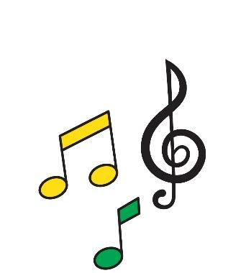
- Use world maps, atlases and globes to identify the UK and its countries, as well as the countries, continents and oceans studied at this key stage.

Music

In spring term for Music, we will cover these song topics:
- I Wanna Play In A Band
- Zootime

Art
This term pupils will be creating self-portraits.

D.T.

- Pupils will learn about a balanced diet.
- They will have the opportunity to design and make a healthy wrap.
- They will describe the taste, texture and smell of a given food.
- Think of four different wrap ideas, considering flavour combinations.
- Construct a wrap that meets the design brief and their plan.

PSHE/SMSC/SEL/RSE
- In SMSC Pupils will explore the topic ‘Celebrating Differences’ and pupils will also explore the topic ‘Healthy Me’.
- In Religious Education, pupils will continue to learn about Judaism. They will also have the opportunity to learn about Christianity.

Diversity We are all different, we are all wonderful.
We will share these carefully chosen ‘Five Favourite’ stories to celebrate our identity in the world and gain a more in depth understanding of others.
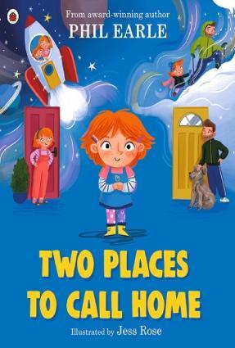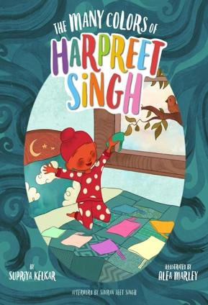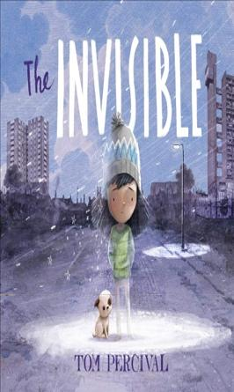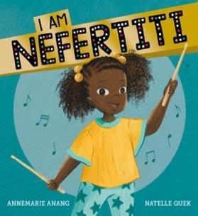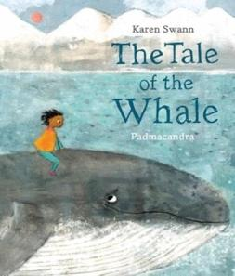

Homework
Your child will receive spellings each Monday and spelling tests will take place every Friday.
RWI Phonics books and Book Bags Books will also be sent home by their phonics teachers. Please encourage your child to read regularly at home. Other homework will be sent out as necessary, with a specified return date.

Many thanks for your continued support,
Year 2 teachers.

