Riverside Primary School
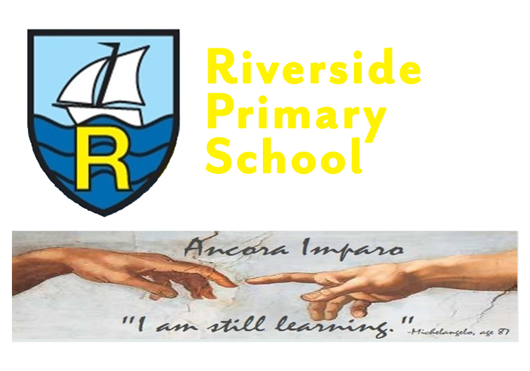
Information to parents- Spring Term- Year 1
Highlights of the Autumn term

What a start we have had! The children have settled in so well to year 1 life and have been working really hard. Here are a few of our highlights so far:
- Cuppa and Cheer! We loved being able to share with you our British Hero song and Conker class poem.
- Being able to share with you the childrens beautiful nativity.
- We were lucky enough to visit The Floral Pavillion to see the wonderful pantomime ‘Jack and the Beanstalk’.

Don’t forget to follow us on Twitter to keep up to date with our new adventures for this term.
@RPS_Conkers

Whats next this term

Maths
Pupils will be working to achieve the following objectives:
Number - number and place value
- Read and write numbers to 50
- Partitioning numbers into tens and ones
- Knowing numbers one more and one less to 50
- Comparing objects and numbers within 50
- Ordering numbers within 50
- Counting in 2’s and 5’s

Number – addition & subtraction
- Add by counting on
- Find and make number bonds
- Add by making 10
- Subtraction- not crossing 10
- Subtraction- crossing 10
- Compare number sentences

Measurement: length & height, weight & volume
- Compare lengths and heights
- Measure length
- Measure and compare mass
- Measure and compare capacity and volume

English

Talk Through Stories

- Every 2 weeks we will share a story to extend and deepen new vocabulary. We explore character and plot. We will talk about stories and build ideas for our own story writing.
- Pupils will learn to write simple sentences using the correct punctuation; capital letters, finger spaces and full stops.

We will be celebrating World Book day on 7th March- we will continue with our popular Word book day activity- decorate your own t-shirt with our favourite book character. Please do not buy a costume as we will be celebrating this day by wearing our tshirts. Why not use the money to purchase a new book and immerse yourself into a new world together.
Phonics
Read Write, Inc

- Everyday we learn to read and write in our Read, Write, Inc groups.
- Pupils will learn to learn to read and spell sounds and words using the sounds they know. (Year 1 focus on Set 2 and Set 3)
- Pupils will learn to decode their matched phonic story books and develop fluency.
- Pupils will write simple sentences with the correct punctuation; capital letters, finger spaces and full stops.
- Pupils will begin to extend their writing into short compositions.
**We will be preparing for our Year 1 phonics screening check**

Science
- Pupils will study materials
- Trip to a wonderful farm
- Pupils will learn all about animals
P.E

Year 1 will have P.E on Tuesday afternoons
This term the children will be working on the following PE skills:
Dance and athletics.

Computing
- Pupils will continue do the following : use the Virtual Learning Environment, internet research, coding and learn how to make an animated story book. Children will also learn how to stay safe on the internet.

History
Pupils will investigate their history topic through the following question:
Who was Neil Armstrong and why is he famous?

Geography

- Pupils will learn about The United Kingdom.

Art
- Pupils will look at creating self-portraits

Music

- Pupils will improve their performing skills through singing and playing instruments.
D.T.

- Pupils will learn about preparing fruit and vegetables as part of a healthy balanced diet.

PSHE - SMSC/SEL/RSE
Pupils will study the following units:
- Pupils will discuss aspirations and how to set and achieve goals and understand the emotions that go with this.
- Pupils will understand how to keep safe and healthy.
RE

- Pupils will continue to learn about Christianity- What do Christians believe about
Jesus? What do Christians believe about love?
- Pupils will learn about what Muslims believe about Allah.

Diversity We’re all different, we’re all wonderful.
- We will share these new carefully chosen favourite five stories to celebrate our identity in the world and gain a more in depth understanding of others.

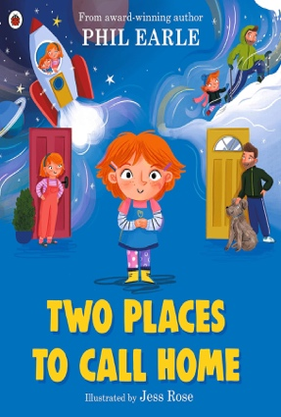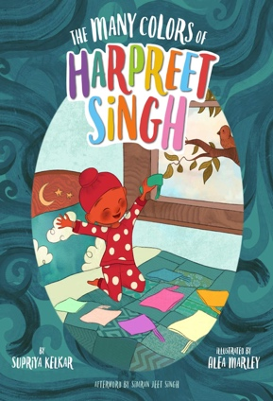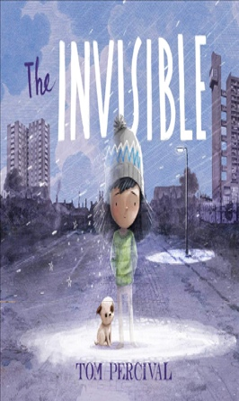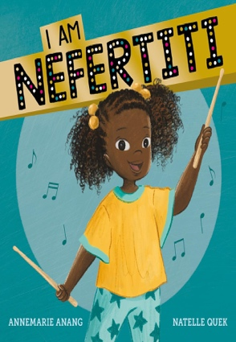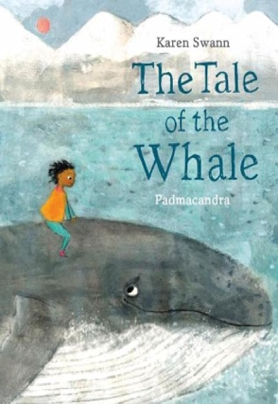

Homework
Maths:
Regular homework is set on mathletics.
Reading:
Please read with your child everyday. They will read their Read Write Inc book and a ‘Book Bag Book’ each week. They will greatly benefit from reading the same stories again and again to build fluency.
Shared reading for pleasure
Each week children will bring the familiar books from Talk Through Stories or a Treasure Chest for you to read and share with them for pleasure.
Spellings:
Your child will learn to spell in Read, Write, Inc lessons every day. Children have a spelling book to practice these spellings. They will bring this home in their book bags. Please practice these spellings with your child. We look forward to seeing their home practice in these books.

Parents evening will take place the week commencing 27th February- dates and times will be available to book closer to the date.

Many thanks for your continued support,
Mrs. Niccolls, Ms Elliot & Mrs Richards

