Riverside Primary School
Information to Parents – Spring Term – Seedlings
Our Top Highlights from the Autumn Term:
- The farm to visit Father Christmas- “It’s been such a magical day.”
- Little Explorers - “I’ve loved coming in every week for some quality time.”
- Little Explorer’s Christmas Sing Along- “That was so magical.”
- Exploring autumn
- Nursery rhyme week
- Celebrations and festivals from around the world
Diary Dates:
- Parents Evenings 27th and 28th of February
- Little Explorers will continue every Wednesday 8:45 am for morning attenders and 12:15 pm for afternoon attenders
- World Book Day 7th of March
Personal, Social and Emotional Development
- This term will begin with the children continuing to explore their environment and developing relationships with their peers, playing alongside them with confidence and welcoming new children to our class
- Develop their own opinions in regards to things they like and dislike
- Can express both positive and negative emotions through actions and speech, also beginning to name and understand the reasoning behind some of these emotions
- Continue to participate meaningfully in co-operative games, with an evolving sense of tolerance for turn-taking
- Reinforce the core values of our school and begin to further understand what they mean
- Use of age-appropriate books to support understanding of emotions

Communication and Language
- Daily mouth and tongue exercises to strengthen oracy abilities
- Dedicated quiet area for specific group work to build upon early speech skills
- Develop all areas of the ‘communication chain receptive language factors’ as outlined in Elklan Language and Literacy Early Years Professional Development Programme
- Children will be able to follow simple verbal instructions
- Use different types of everyday words including nouns, verbs and some adjectives
- Listens to and enjoys rhythmic patterns in rhymes and stories, sometimes anticipating repeated refrains
- Learns new words rapidly and is able to use them in communicating

Physical Development
- Daily dough disco to build strength and dexterity in our small hands, especially in our fingers
- Malleable material area freely accessible to practice dough disco skills independently
- Daily music and movement opportunities including dancing, yoga, stretching and ballet
- Fostering an environment of independence with regards to hand hygiene, including an understanding of the importance of this
- Children to also aid dressing and undressing themselves, such as pulling zips up and down on coats and putting their own coats on
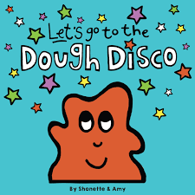
- Develops increasing control over a range of objects and tools
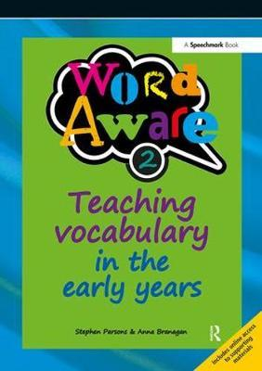
Literacy
Reading
- Follow the Word Aware Vocabulary scheme to introduce a new word complete with the Makaton sign each day
- Have a focus book each week that we read daily, to ensure understanding of the context and vocabulary
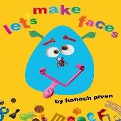
- Some of the books we will be using this term are:
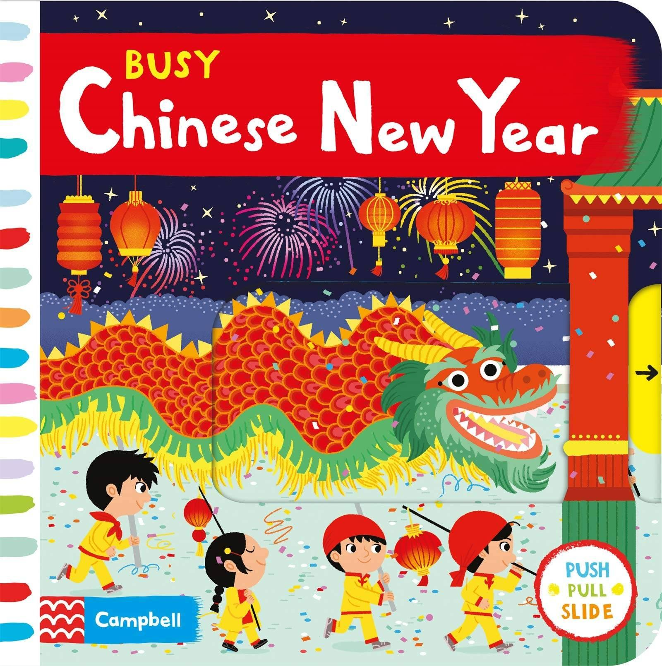
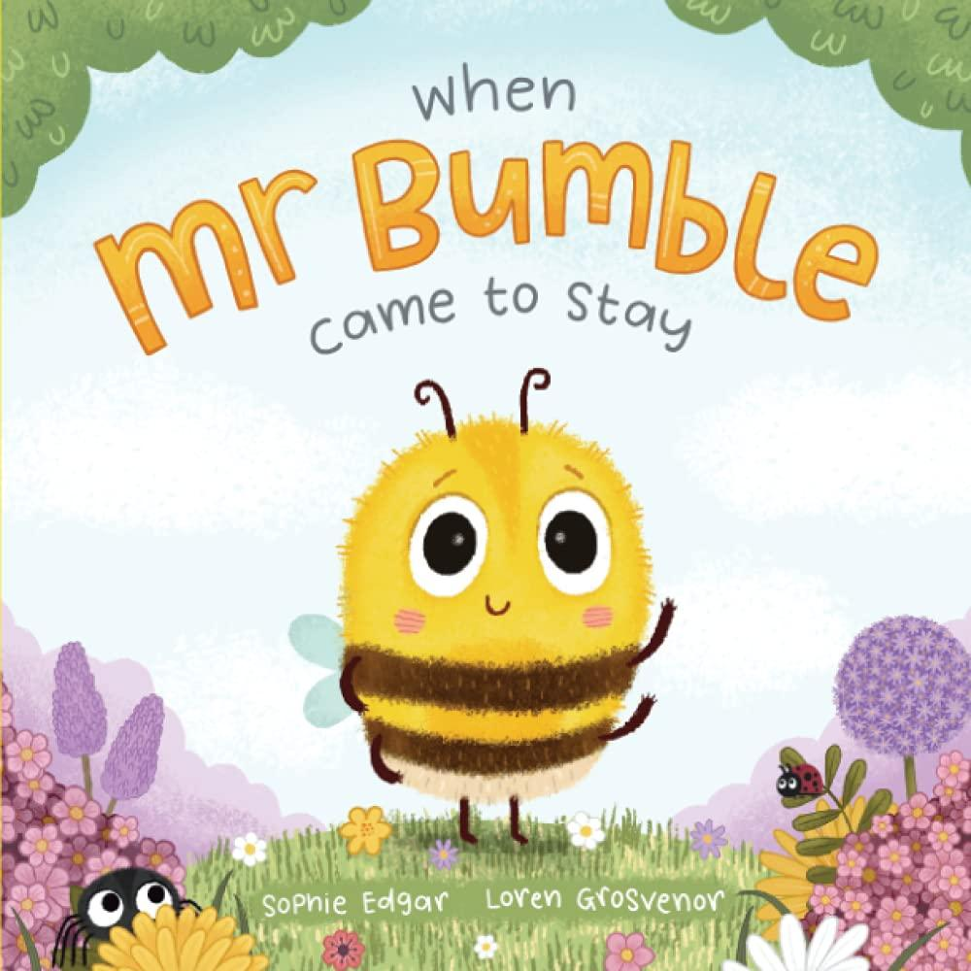
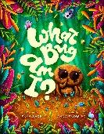
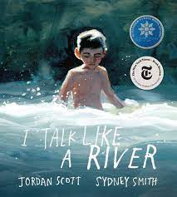

Writing
- Daily mark-making opportunities in a variety of creative ways, using tools and fingers with different materials to create linear and circular shapes
- Malleable materials provided freely each day, combined with dough disco to strengthen fingers and improve dexterity

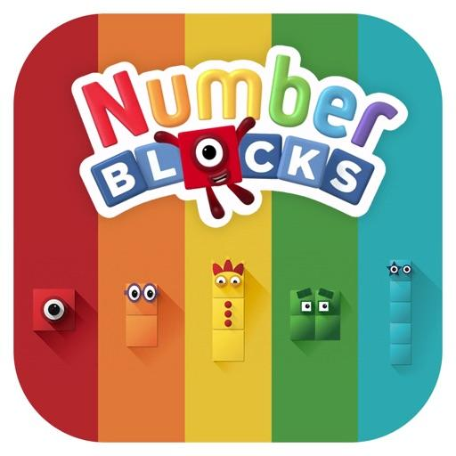
Maths
Number
- Join in with number songs that count in ascending and descending sequences, but also require active participation, e.g. Five Little Speckled Frogs
- Counting in everyday contexts, e.g. how many boys are in today? How many girls? How many children is that altogether?
- In everyday situations, can give or take objects from a group
- Use familiar characters and media to foster an enjoyment of number play, e.g. hiding Number Blocks in messy play
Shape, Space and Measure
- Enjoys filling and emptying containers, as well as squeezing themselves into small spaces
- Is interested in what happens next with regards to the everyday routine
- Enjoys using blocks and similar equipment to create their own simple structures and arrangements
- Chooses puzzle pieces and tries to fit them into the inset boards
- Explores how things look from different viewpoints

Understanding of the World
- Seedling children will be exploring the topics of Chinese New Year and Easter through a wide range of activities
- Learning all about themselves including what features make them similar to others and what makes them unique
- How we can care for our natural environment, including the important job of protecting our bees
- Why minibeasts are, in fact, amazing!
- How to use a camera to take photos of particular importance, e.g. when on a minibeast hunt, when comparing eye colours etc.
- Plays with water to investigate how it can be manipulated for washing: for pipe structures, cleaning through the inclusion of dolls clothes to wash, tubing and funnels to piece together and creating a toy car wash
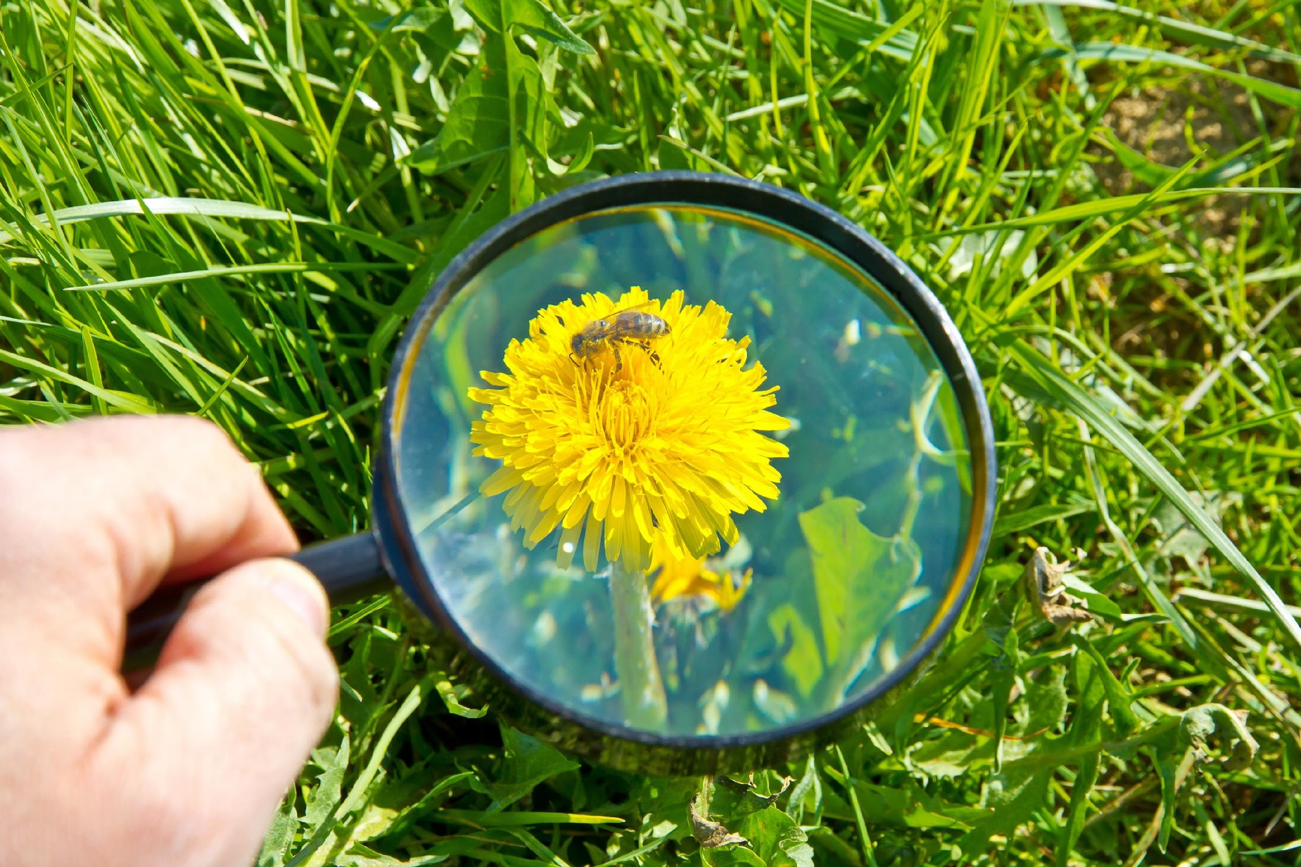
- Can match parts of objects that fit together, e.g. teapot and the lid
- Internet Safety Day

Expressive Arts and Design
- Enjoys a wide range of music and will often dance along to their choice of favourite songs
- Can sing and vocalise sounds either with music or instruments
- Uses their own knowledge of everyday situations and applies this to their play, e.g. uses a brush to comb through a person’s hair
- Enjoys being creative using a wide range of materials, sometimes with a specific outcome in mind
- Beginning to understand that combining colours can result in a change.

Don’t forget to check out our Seedlings Twitter page following the link below
@RPS_Seedlings

Happy New Year!
Many thanks for your continued support,

Mrs Balls, Mrs Elliott and Miss Smith

