Riverside Primary School
Information to parents- Spring Term- Otter Class

Our Top 10 moments from Autumn Term
- Croxteth Farm to meet Father Christmas
- Coffee afternoon
- Diwali
- Nursery Rhyme Week
- Weekly cooking sessions
- Christmas and Nativity show
What our children and parents have to say:
“Today has been the best day ever!”
“What a magical expereince for the children.”
“This is so yummy, can I have some more please?”

“That was such a lovely Nativity, I really enjoyed watching it!”

Personal, Social & Emotional Development:
This term we will be learning how to develop our resilience and perseverance when dealing with challenges. Pupils will begin to identify and moderate their own feelings, socially and emotionally. We will be developing our independence when dressing and undressing (our coats and school hoodies) in school. We will also continue to focus on using positive vocabulary to one another at all times. Our classroom is a calm and happy environment to learn and we will continue to use our self-regulation techniques, including meditation as part of our everyday school life.

In our weekly Jigsaw lessons this term, we will identify our own dreams and goals for the future and look at how we can be healthy.

Physical Development:
We will continue to follow the Edsential PE scheme, with a focus on learning how to control a ball. Later in the term, we will be working on our balance.
P.E will continue to be every Tuesday morning. We will continue our daily Dough Disco to improve our fine motor development. This term we will also be focusing on handling scissors, glue sticks and pencils effectively, as well as our cutlery at lunch time.

Communication & Language
This term we will be continuing to use Voice21 to aid our development in Communication and Language. We will be looking at key areas such as:
- Continuing to learn techniques in order to initiate a conversation with our peers
- Learning how to build on what others are saying
- Developing talking in full sentences using conjunctions such as ‘and/because’
- Expressing our own ideas and feelings
- Maintaining eye contact and using hand gestures

Literacy:
Children’s will act out stories, be able to talk about the characters in the books they are reading and writing CVC words. Some will begin to write simple sentences this term.
To support our children with this, we will be focusing on the following texts:

- Three Little Pigs
- Three Billy Goats Gruff
- Jack and the Beanstalk
- Handa’s Surprise
- Billy’s Sunflowe
- Lost and Found
- After The Fall
- If You Were A Penguin
Phonics
This term we will continue on our Phonics journey and we will deepen our understanding of all Set 1 and Set 1 Special Friends RWI sounds. Phonics is taught each morning and speed sound sessions every afternoon. Each week, we will continue to send home virtual classroom links and handwriting sheets.
Well done to you all for all your hard work and commitment to learning to read in the autumn term. We are all so proud of the progress you are making.

Maths
Pupils will be working to achieve the following objectives:
- Part and whole
- Sequencing and positional language
- More and less
- Height, length and capacity
- Patterns and 2-D shapes
- Subsidising within 10
- Composition of numbers and counting
UTW: (Understanding the World)
During this term we will be learning about the different seasons, particularly winter, spring and life cycles. We will be completing experiments involving ice and also plants. We will be celebrating Chinese New Year, Ramadan and Easter. This term will centre on learning about machinery and how things in the past looked differently to things today. We will be learning how to use and make basic maps and about our local area in more detail.

Expressive Arts and Design:

Pupils will be taught to mix colours and getting creative, learning about different materials. We will be cooking in class each week with Miss D. We will be completing weekly music lessons and learning nursery rhymes. We now have a ‘Nursery Rhyme of the Week,’ which we sing every day. Some of the nursery rhymes we will be focusing on this term are: Five Little Snowmen, Here We Go Round the Mulberry Bush, Old McDonald, Hot Cross Buns and Baa Baa Black Sheep.

Diversity Story Books: We’re all different, we’re all wonderful
We will share these new carefully chosen favourite five stories to celebrate our identity in the world and gain a more in depth understanding of others.
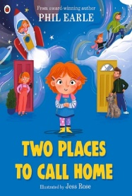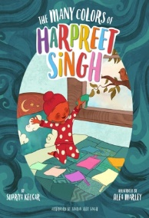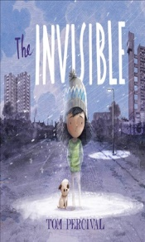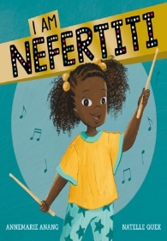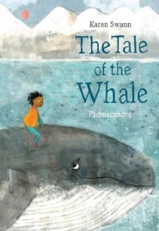

Don’t forget to follow us on Twitter to see all our latest news at @RPS_Otters

Thank you for all your support so far this year, we are really looking forward to another wonderful term together in Otter class!
Team F2

