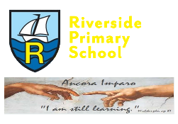
Riverside Primary School
Information to parents – Spring Term – Foundation One

Highlights of the Autumn term

Our Top 10 moments from Autumn Term
- Croxteth Farm
- Coffee afternoon
- Weekly walks along the prom
- Diwali
- Nursery Rhyme Week
- Michael Rosen poem
- The beginning of ‘Make Your Own Lunch’
- Making our own delicious soup
- Christmas and Nativity show
- The Nutcracker
What our children and parents have to say:
“This is the best day ever!”
“Thank you to all the teachers for such a lovely day.”
“This is so yummy, can I have some more please?”

“Ah, that was such a lovely Nativity, I really enjoyed watching it!”

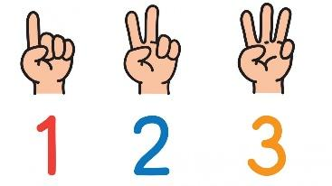
Maths
Pupils will be working to achieve the following objectives:
Number
- Take part in finger rhymes with numbers
- Count in everyday contexts, sometimes skipping numbers – ‘1-2-3-5’
- Combine objects like stacking blocks and cups; put objects inside others and take them out again
- Compare amounts using vocabulary such as, ‘lots,’ d‘more’ or ‘same’
- Begin to develop recognition of up to 3 objects on sight, without counting them (subitising).
- Recite numbers past 5
- Match number names to quantity and numerals
- Touch count different arrangements and recognise the final number is the quantity of the set
- Children count forwards and backwards to 4
- Children will subitise sets of up to 4 objects to find the total
- Begin to solve number problems in everyday life
Shape, Space and Measure
- Climb and squeeze themselves into different sized spaces
- Build with a range of resources
- Complete inset puzzles
- Compare sizes, weights etc. using gesture and language - ‘bigger/little/smaller,’ ‘high/low,’ ‘tall,’ and ‘heavy’
- Notice and arrange items into patterns?
- Use mathematical language in regards to weight, such as: ‘heavy,’ ‘heavier,’ ‘heaviest’ and ‘light’, ‘lighter’ and ‘lightest’
- Use mathematical language in terms of length, using cubes and different measuring tools to describe heights
Reading
In Foundation One, we are reading a variety of literature to promote a love of reading.
We are learning to:
- Enjoy sharing books with an adult
- Pay attention and respond to the pictures or the words
- Have favourite books that we share with an adult, another child, or enjoy alone
- Repeat words and phrases from familiar stories
- Ask questions about books
- Make comments and share their own ideas
- Develop play around favourite stories using props
Writing
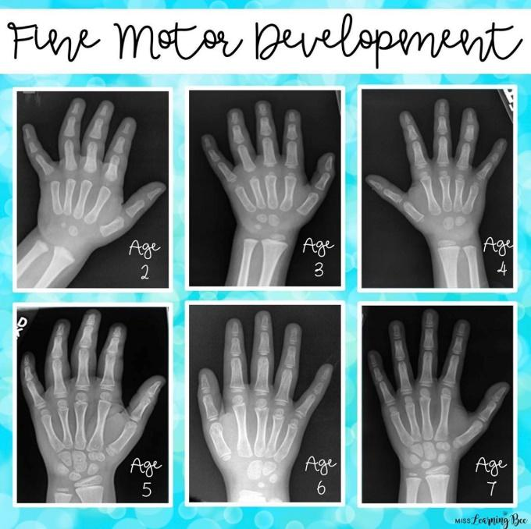
This term, we are looking at mark making and pre-writing skills. We are completing a range of fine motor activities to support early writing development, including:
- Pencil Disco
- Dough Disco
- Funky Fingers activities
- Pencil control

Understanding the World
Throughout the Spring term, Acorns will be exploring different aspects of their world. They will:
- Explore and respond to different natural occurrences in their setting
- Begin to make sense of their own life-story and family’s history
- Talk about what they see, using a wide vocabulary
- Explore how things work
- Begin to understand the need to respect and care for the natural environment and all living things
Safer Internet Day – 6th February

Life Cycles
Pupils are learning about animals and wildlife. They will explore animal lifecycles and begin to understand how they grow and change.

Winter
Pupils are observing the changes in the world around them as the seasons change. They will learn about animals and understand why they hibernate.
Spring
Pupils will observe the changes from winter to spring and comment on what they see in the environment.
Pupils will look at the growth of seeds and plant their own, commenting on the changes they observe.
Pupils will show an interest in minibeasts and animals. They will explore the lifecycle of frogs and caterpillars.
Celebrations
Religious Festivals – Epiphany and Twelfth Night – 6th January
Religious Festivals – Lunar New Year 10th February
Religious Festivals – Shrove Tuesday – 13th February
Religious Festivals – St David’s Day – 1st March
Religious Festivals – St Patrick’s Day – 17th March
Religious Festivals – St George’s Day – 23rd April
Religious Festivals – Easter – 29th March – 1st April

Expressive Arts and Design
Pupils are going to:
- Begin to make marks intentionally
- Explore paint using fingers and other parts of their bodies, as well as brushes and other tools
- Express ideas and feelings through mark making, and sometimes give meaning to the marks they make
- Enjoy and take part in action songs, such as ‘Twinkle, Twinkle Little Star’
- Develop imaginative play, pretending that one object represents another, e.g. a child holds a wooden block to her ear and pretends it is a phone
- Explore and investigate different materials using all their senses
- Manipulate and play with different materials
- Use their imagination as they consider what they can use different materials for
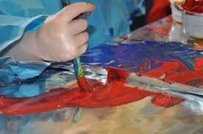
- Make simple models which express their ideas
- Explore colour and colour mixing
- Listen with increased attention to sounds.

Physical Development
Acorns take part in Fitness Friday. This term Acorns are learning to:
- Use large and small motor skills to do things independently, for example, manage buttons and zips, and pour drinks
- Show an increasing desire to be independent, such as feeding themselves
- Learn how to use a knife and fork, independently
- Continue to develop their movement: balancing, riding (scooters, trikes and bikes) and ball skills
- Go up steps and stairs confidently or climb up apparatus using alternate feet
- Skip, hop, stand on one leg and hold a pose for a game such as musical statues
- Use large-muscle movements to wave flags and streamers, paint and make marks

Personal, Social and Emotional Development
Pupils are learning to become more independent. They are beginning to put on their coats unaided and manage their self-care with the support of adults in nursery. Pupils are learning to follow our core values and apply them to their relationships with their peers.
- Notice and ask questions about differences such as: skin colour, types of hair, gender, special needs and disabilities, religion and so on
- Develop friendships with other children
- Safely explore emotions beyond their normal range through play and stories
- Talk about their feelings in more elaborated ways: “I’m sad because…” or “I love it when …”
- Learn to use the toilet with help, and then independently
- Develop their sense of responsibility and membership of a community
- Become more outgoing with unfamiliar people, in the safe context of their setting
- Show more confidence in new social situations

Communication and Language
Pupils are constantly developing their language skills through play and provision that provokes interest.
- Begin to say how they are feeling, using words as well as actions
- Begin to develop conversation, often jumping from topic to topic
- Develop pretend play, e.g. putting the baby to sleep or driving the car to the shops.
- Listen to simple stories and understand what is happening, with the help of the pictures
- Identify familiar objects and properties when they are described, e.g. ‘Katie’s coat,’ ‘blue car’
- Understand and act on longer sentences like ‘make teddy jump’ or ‘find your coat’
- Use a wider range of vocabulary.

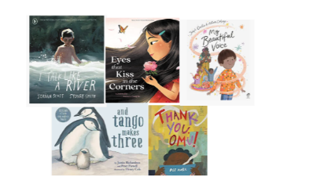
Diversity
We are all different, we are all wonderful.
We will share these carefully chosen five favourite stories
to celebrate our identity in the world and gain a more in depth
understanding of others.

Parents/Carers Meetings:
An opportunity to look at your children’s work and discuss their progress with their class teachers between 27th and 28th February 2024. You will be able to book your slots online on the Arbor app.
Cuppa – Chant and Cheer!
Join us at a special Easter workshop during the week beginning the 20th March – times allocated for our class will follow.

Dates for your diary
Trip to Liverpool Walker Art Gallery – Friday 1st March
Trip to Eaton Farm – Tuesday 19th March

Don’t forget to check out our Acorns Twitter page following the link below or scanning the QR code.
@RPS_Acorns

Happy New Year!
Many thanks for your continued support,

Miss McNabb and Mrs Whelan

