C. Carr (Co-chair of Governors)
C. Lahive (Headteacher)

Special Educational Needs and Disabilities
Coordinator (SENDCo): Mrs F. Benson
SEND Governor: Mrs M.Lyons
All Wirral Local Authority (LA) maintained schools have a similar approach to meeting the needs of pupils with Special Educational Needs and are supported by the LA to ensure that all pupils, regardless of their specific needs, make the best possible progress in school. All schools are supported to be as inclusive as possible, with the needs of pupils with Special Educational needs and Disabilities being met in a mainstream setting wherever possible.
The four broad areas of need are: Communication and Interaction, Cognition and Learning, Social, Emotional and Mental Health Difficulties, and Sensory and Physical Needs.
What is the local offer?
The Children and Families Bill, enacted in 2014, states that Local Authorities and schools are expected to publish and keep under review information about services they expect to be available for the children and young people with SEN aged 0-25. This is the ‘Local offer’.
The intention of the Local offer is to improve choice and transparency for families. It will also be an important resource for parents in understanding the range of services and provision in the local area.

The 'Local Offer' at Riverside Primary
My child has special educational needs. What can you offer at Riverside?
At Riverside we embrace the fact that every child is different and, therefore, the educational needs of every child are different – this is certainly the case for children with Special Educational Needs.
We recognise the importance of early identification of SEN, as this improves the positivity of the outcomes for children.

Identification of Special Educational Needs or Disabilities.

- Identification of SEND may have occurred prior to a pupil’s enrolment at school. If this is the case, then school will seek appropriate advice and support from the relevant school and external agencies. This then informs the provision that is put in place for the pupil at Riverside Primary School.

- When a concern is evident, the class teacher will assess the child’s difficulties (see diagram below) and may draw upon advice from the SENDCo, if necessary. If this additional support/strategies are not effective enough, then it would be necessary to develop an Education Support Plan and further personalise teaching to meet the needs of the pupil.

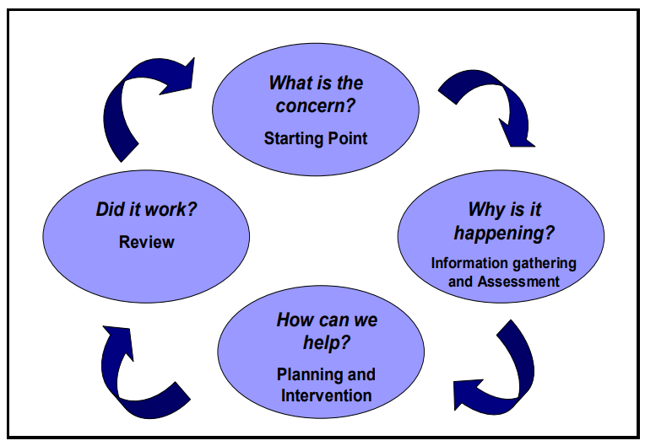

- There is a high level of teaching staff in each year group, to ensure children with SEND are well supported to access the full curriculum within their mainstream classes.

- Where appropriate, outside agencies will be involved and progress will be monitored.

In terms of what we offer children with Special Educational Needs and/or Disabilities, this is different for every child and it is important to emphasise that, as much as possible, this provision is designed by the relevant Riverside staff members working alongside the child, the child’s family and, where necessary, outside agencies* (e.g. a speech and language therapist or an educational psychologist).
How will your child’s needs be met?
Every teacher has a duty to provide Quality First Teaching (QFT) to all pupils. In some cases, ‘reasonable adjustments’ need to be made to allow a child to access learning effectively. Examples of reasonable adjustments could be to provide a sloping board for a child to write on, or written materials to be printed onto coloured paper to help a child read better.
Typically, a child with special educational needs and/or disabilities will have a support plan, which sets out the intended outcomes that are currently being worked towards and what additional provision is put in place for that child. This will also be accompanied by a ‘one-page profile’ of your child, which your child will work with the staff to create. This profile will ensure that every member of staff who works with your child, will have a thorough understanding of his/her needs and how best to support him/her.
For many children, outcomes will be connected to learning and will often be specifically to do with English and mathematics. For other children, they may be to do with social interaction, communicating with children and adults, emotional difficulties, overcoming physical issues (for example, problems to do with fine motor control) … the list is endless! The most important point is this: the intended outcomes depend on the needs of the child.

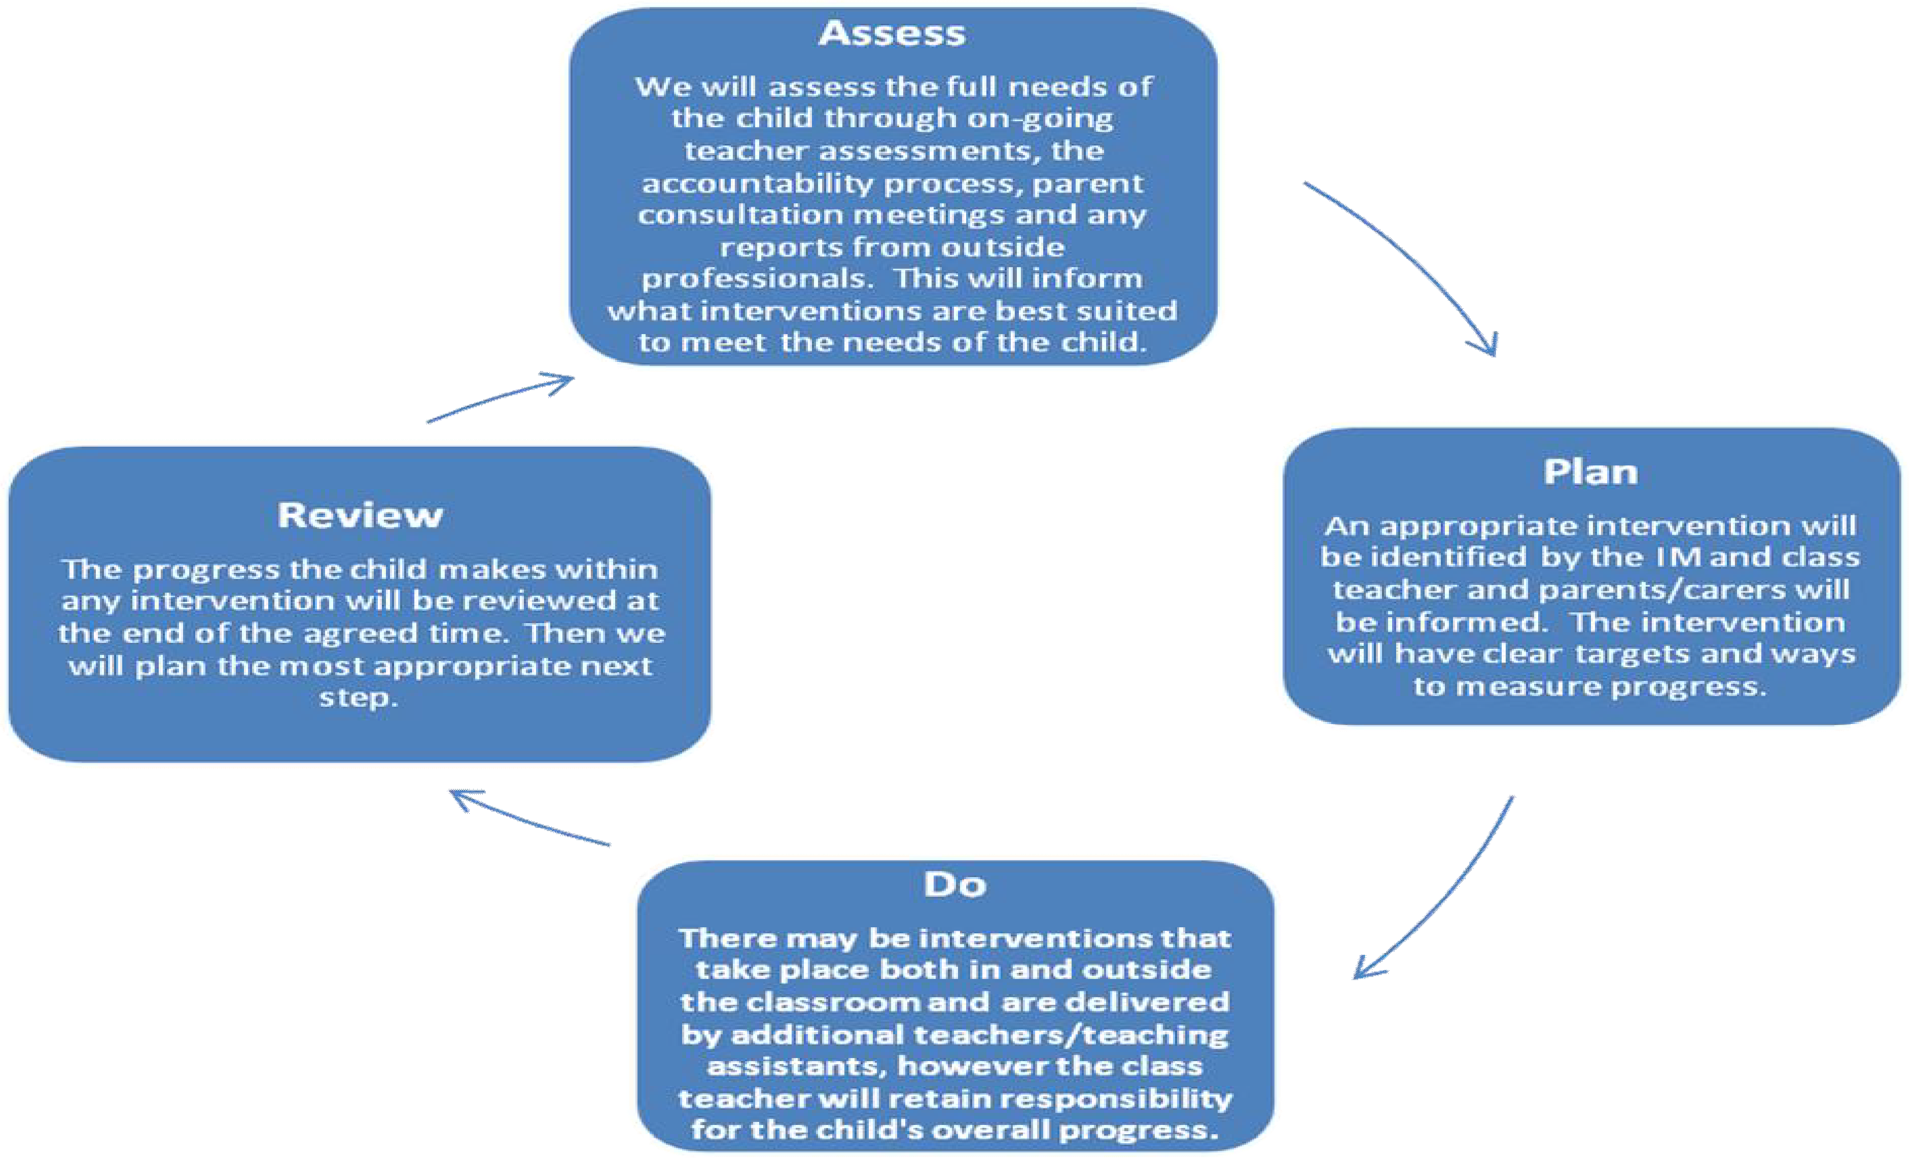
The assess, plan, do, review cycle is key to identifying how effective an intervention or strategy has been.

Additional Provision
The school offers many different forms of additional provision. This can include: additional in-class support; additional out-of-class support; one-to-one support; flexible groupings (including small group work); access to specific resources, such as IDL Literacy to support spelling and reading and IDL Numeracy to support pupils with mathematics.
We also have two academic mentors in school, who support children on an individual basis, working on specific areas of the curriculum.
Speech and language
As a school we recognise the importance of early language skills and every pupil entering F1 (Nursery) or F2 (Reception) will be assessed, through play, on their speech and language skills, using the Wellcomm screening.
In addition to our usual SEN provision, our school buys in the services of a speech and language therapy company called ‘Talk About Town’. We have employed their therapists to provide assessment and therapy sessions for children identified with difficulties in this area. This is in addition to what the NHS speech and language team offer.

All additional provision and outreach services are overseen and evaluated by the school's Senior Leadership Team. Additional provision is designed and implemented by an excellent team of teachers, ably supported by a fantastic group of teaching assistants. Like with individual outcomes, the most important point is this: additional provision depends on the needs of the child.
If your child requires a higher level of support, outside agencies would usually become involved.
What specialist services and expertise are available at or accessed by the school?
Senior leaders, teachers and teaching assistants at Riverside are highly skilled in meeting the individual learning, behavioural and social needs of our children. All staff work collaboratively with the SENDCo and relevant outside agencies to ensure that the provision enables your child to make progress with their learning. The school accesses a range of specialist services /outside agencies including:
- School Nurse (0-19 team)
- Speech and Language Therapy
- Occupational Therapy
- Educational Psychologist
- Specialist outreach support – Gilbrook (behaviour support), ASC Team and Orrets Meadow (dyslexia support).
- CAMHS support (including weekly sessions for identified pupils)
- Integrated Front Door (social services support)
- Social Care Family Support Worker
- Wired Parent Partnership
- Early Help/ Community Matters
- Paediatricians – accessed via school nurse and/or GPs
- Local Authority EHCP team

The highest level of support is available for children whose learning needs are severe, complex and lifelong. This is usually provided via an Education, Health and Care Plan (EHCP). The school (or you) can request that LA services carry out a statutory assessment of your child’s needs. This is a legal process, which sets out the amount of support/provision that will be provided for your child.

Inclusion bases
‘The Willows’ is a local authority funded inclusion base, which supports children (aged between five and eight) with emotional and behavioural difficulties. The base supports children from across the Wirral. Places in ‘The Willows’ are determined by the local authority, following the pupils being assessed by a specialist panel of professionals. Children usually spend between two and four terms in the Willows, before either returning to their original school or moving on to specialist provision.
‘The Ferns’ is a new local authority funded base which provides similar support as The Willows, but is aimed at supporting children from Year Two to Year Five. The Local authority’s SEN base panel assess the suitably of children to access this provision also.

Mental Health and Well-being

Whilst Mrs Benson is the designated Mental Health lead in school, we recognise the importance of a holistic approach. Therefore, there is a Mental Health Team, which consists of: Mrs Lahive (Headteacher), Mrs Benson (Assistant Headteacher and SENDCo), Mrs Airosa (Inclusion base teacher), Mrs Bowness (Pastoral lead) and Miss Evans (Attendance), whom work together to improve outcomes for children across the school.
One part of our approach to mental wellbeing is ‘Power Pack’ for KS2 pupils, which runs weekly. This club supports children who have experienced loss (possibly through bereavement) or trauma, and need extra support, from specially trained staff.
Riverside uses the ‘My Happy Mind’ programme to provide a whole school approach to creating and supporting positive mental health. Each year group engages in weekly sessions, which build up the children and staff’s awareness of how to ensure these important life lessons are taught in a structured and age appropriate way.
The school also work closely with the Child, Adolescent Mental Health Service (CAMHS), who offer weekly sessions to individual and identified groups of pupils.

Medical Needs
For children who have additional medical needs, the support that school can offer includes:
- If a pupil has a medical need then a detailed Individual Health Care Plan (IHCP) is compiled with support from the 0-19 Team and advice from any other relevant medical professionals in consultation with parents/carers. These IHCPs are then shared with all adult stakeholders within the school to ensure that the child’s medical needs are met.
- In agreement with parents/carers medicines are administered in school, but only where a signed medical consent form is in place to ensure the safety of both child and staff member. Children on medication that would need to be administered at school would need an IHCP in place.
- Most staff are trained in how to use a defibrillator and school has one on the premises.
- All adults working within the school are made aware of children with specific medical needs via the medical communication board located inside the staffroom and main office.
Disability access and arrangements for the admission of disabled pupils
Please refer to our full accessibility plan, which can be located within the policies section of our website.

Transition
How will the school prepare and support my child when joining Riverside or transferring to a new school?
Parents and children are welcome to look around Riverside, by booking a prior appointment with the school office, to see the excellent provision we offer and whether you feel we can meet the needs of your child.
Your child, if particularly worried or anxious, will be offered some transition visits and an opportunity to meet their new class teacher and their peers.
Transition to secondary school can also be a worrying time for both parents/carers and the child, so at Riverside, we do additional transition visits and talk at length to secondary school SENDCos about each child. We ensure all paperwork (particularly if the child has Special Educational needs) is passed on to them and they are made aware of any special requirements, both educationally and pastorally. The One Page Profiles we create are an excellent tool for supporting the transition process. Some pupils also benefit from creating ‘Communication passports’ with the help of their Y6 teachers, which help new staff in the secondary schools understand what the pupils may struggle to communicate verbally.
How has Riverside responded to the challenges presented by COVID 19?
We recognise that children have had differing experiences during the pandemic and all Riverside staff are aware of and sensitive to the needs of the pupils.
To give the children the best opportunities to thrive and accelerate their learning this year, most year groups have two teachers, to minimise teaching group sizes and allow staff to give children more individual attention.
Pupils in both Key Stages also benefit from small group work which includes IDL Literacy/Numeracy sessions with an academic mentor and one to one phonic sessions.
The online learning platform provided by the school website offers additional phonics sessions, to plug any gaps in learning.
IDL Literacy and Numeracy support programmes can also be accessed from home, supporting the learning which goes on in school.

All Riverside pupils benefit from a range of teaching and learning styles. We pride ourselves on our inclusivity and will do our utmost to adapt our practices to meet the needs of every pupil in our school.

Who can I contact for further information or if I have any issues or concerns?
The first point of contact for anything related to your child’s education is the class teacher. We encourage parents not to wait for the next formal opportunity to meet, but to contact us on an ongoing basis.

If necessary, the SENDCo, the Deputy or Head Teacher will be available to talk to you at a mutually convenient time. If you feel your matter still has not been dealt with you can follow the procedures outlined in our school complaints policy, which is on our school website, under the policies section.

For more information about our ‘Local Offer’ for children with Special Educational Needs and/or Disabilities, and/or if you have any questions or queries about SEND, please speak to Mrs Benson via the school office on 0151 639 9787 or via email: bensonf@riverside.wirral.sch.uk

